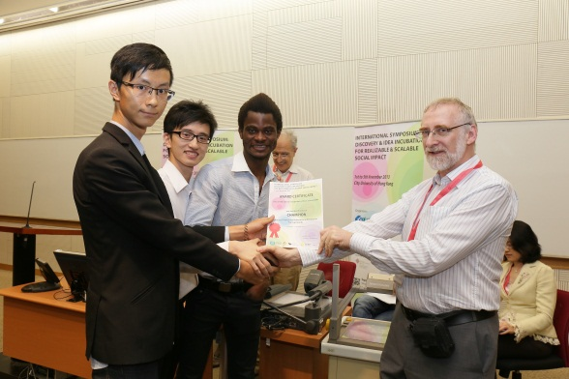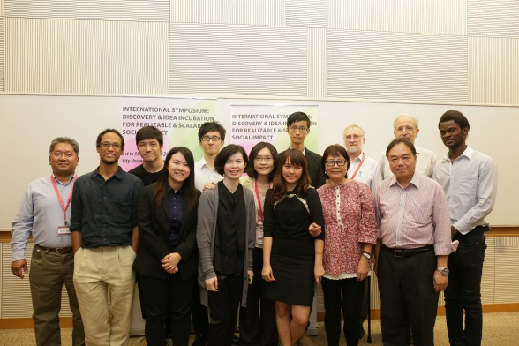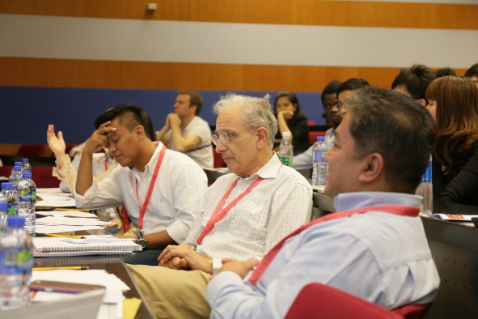

To Yutian,

This part stays on top of the page

PROJECT FLAME SYMPOSIUM 2014

**UNIVERSITIES AS WORLD CHANGERS**

31st October & 1st November

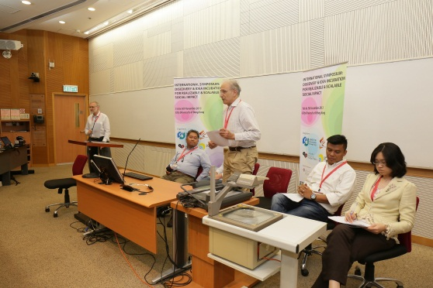[About](http://www6.cityu.edu.hk/projectflame/symposium/#about) the Symposium

* *With so many social, economic and environmental problems facing us, what parts can universities, students, social innovators and entrepreneurs and other concerned individuals play in creating a better world?*
* *To discover some answers to this question, then you must join Project Flame Symposium: Universities as World Changers on Friday 31st October and Saturday 1st November 2014.*

*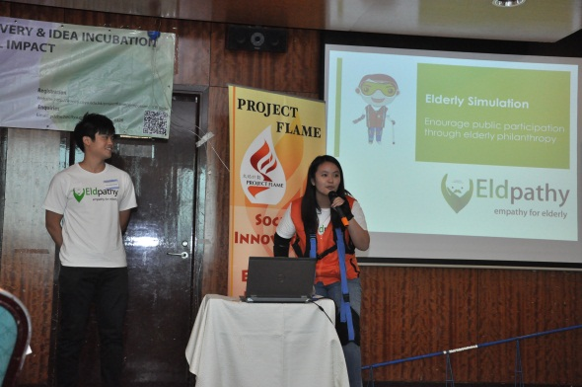*

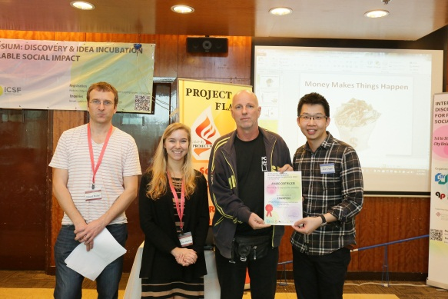

**D**uring the symposium, international and local experts in social innovation and enterprise will be sharing their experiences. The focus will be on helping people who are passionate about fostering enterprising ideas for social innovation and on incubating, developing or scaling-up social ventures.

[Speakers](http://www6.cityu.edu.hk/projectflame/symposium/#speakers)

**Keynote Speakers**

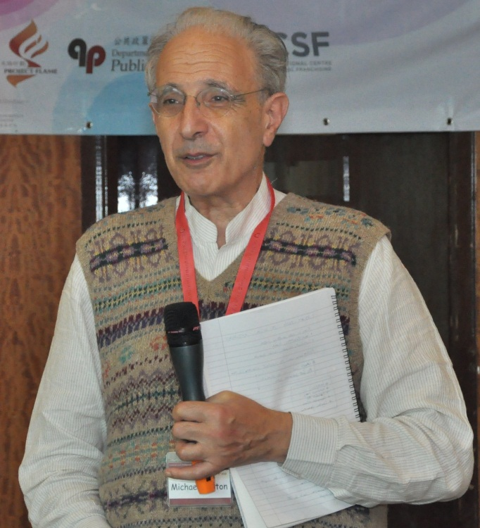

### Adam O’Boyle

Executive Director of Hub Ventures, Co-founder of Student Hubs and Turl Street Kitchen

### C:\Users\qianqmai2\Google Drive\International Symposium 2014\Website Design\Photos\Keynote Speaker_Adam Boyle.jpeg

### Michael Norton OBE

Social Innovator, Co-Founder of UnLtd and the International Centre for Social Franchising; author of 365 Ways to Change the World, The Everyday Activist, The Complete Fundraising Handbook and the WorldWide Fundraisers Handbook.

(photo from <http://www.generationchange.org.uk>)

**Other Speakers and Facilitators Include:**

David **B**ishop (Principal Lecturer, School of Business, the University of Hong Kong)

Yanto **C**handra (PhD, Associate Co-Director, Project Flame, City University of Hong Kong)

Kelvin **C**heung (CEO, UnLtd Hong Kong; Founder & CEO, FoodCycle UK)

Wendy **C**heung (Manager of Green Ladies, St. James Settlement)

Joseph **F**ernandez (Founder and Director of Trade Without Borders)

Mark **H**ayllar (PhD, Associate Director of Project Flame, City University of Hong Kong)

Reza **H**oshmand (Professor, Director of General Education, Hong Kong Baptist University)

Elizabeth **L**ai (PhD, Founder and Director of Reconnect Environment)

Josephine **L**ee (Deputy Chief Executive Officer, St. James Settlement)

Hugh **T**homas (Professor, Associate Director, Center for Entrepreneurship, Chinese University of Hong Kong)

Linda **W**ong (Professor, Director of Project Flame, City University of Hong Kong)

**Keep watching for further updates on speakers!**

[Schedule](http://www6.cityu.edu.hk/projectflame/symposium/#schedule)

|  |  |  |  |
| --- | --- | --- | --- |
| Day 1  Oct 31st 2014 (Friday) | | | |
|  | | Speakers | Venue |
| Morning Session | | | To be announced.  *Please follow our updates on the webpage and the email confirmation for the registered participants.* |
| 9:00 | Registration |  |
| 9:30 | Welcoming Remarks |  |
| 9:50 | Introduction to the Symposium | Dr. Mark Hayllar |
| 10:00 | Keynote Sharing:  *Leveraging on University Capacities for Building a Better World* | Prof. Michael Norton |
| 11:00 | Tea/ Coffee |  |
| 11:15 | Case Study Presentations:  *Promoting Innovation in the University Context* | Mr. David Bishop (HKU)  Prof. Linda Wong (CityU)  Prof. Reza Hoshmand (HKBU)  Prof. Hugh Thomas (CUHK) |
| 12:45 | Lunch Break |  |
| Afternoon Session | | |
| 2:00 | Introduction to Pitching Enterprising Ideas for Social Innovation | Prof. Michael Norton |
| 2:15 | *Pitching Enterprising Ideas for Social Innovation*  Presentations by Finalists (Part I) | Finalists & Judging Panel members |
| 3:15 | Tea/ Coffee |  |
| 3:45 | *Pitching Enterprising Ideas for Social Innovation*  Presentations by Finalists (Part II) | Finalists & Judging Panel members |
| 5:15 | Panel and Audience Feedback |  |
| 5:30 | Results Announced / Wrap-up | Prof. Michael Norton |

|  |  |  |  |
| --- | --- | --- | --- |
| Day 2  Nov 1st 2014 (Saturday) | | | |
|  | | Speakers | Venue |
| Morning Session | | | To be announced.  *Please follow our updates on the webpage and the email confirmation for the registered participants.* |
| 9:00 | Registration |  |
| 9:30 | Keynote Sharing:  *Getting from Ideation to Implementation* | Mr. Adam O’Boyle |
| 10:00 | Case Study Presentations:  *Critical Factors in Implementing Social Innovations* | Dr. Yanto Chandra  Dr. Elizabeth Lai (Reconnect Environment) |
| 11:00 | Tea/ Coffee |  |
| 11:15 | Case Study Presentations:  *Critical Factors for Helping Start-ups to become End-ups* | Mr. Joseph Fernandez (Trade Without Borders) |
| 12:45 | Lunch Break |  |
| Afternoon Session | | |
| 2:00 | Keynote Sharing:  *Making a Bigger Impact on the World* | Prof. Michael Norton  Mr. Kelvin Cheung |
| 2:30 | Case Study Presentations:  *Critical Factors for Successful Scaling-up* | Ms. Wendy Cheung (Green Ladies)  Green Monday  Dialogue Experience |
| 4:00 | Tea/ Coffee |  |
| 4:15 | Expert Views:  *Building Capacity for Scaling Up Impact through Social Enterprise Endorsement* | Dr. Mark Hayllar |
| 4:30 | Concluding Plenary:  *Sustaining Impact* | Prof. Michael Norton |

[Pitching](http://www6.cityu.edu.hk/projectflame/symposium/#pitchingAward)

**Pitching Enterprising Ideas for Social Innovation**

There are so many social, economic and environmental today. To create a better world, we need more creative and enterprising ideas urgently.

Are you a student, entrepreneurs or anyone else with an innovative idea that could make a difference, however big or small, and create social and/or environmental impacts?

Come and pitch your creative idea at the Project Flame Symposium and engage with a supportive panel of international and local experts in social innovation and enterprise.

Applicants will have the privilege of attending the Symposium and finalists will be able to pitch their ideas and maybe win a Project Flame award.

## ACT NOW!

Register

To Yutian, please link this to the pitching registration form in the registration tag

Project Flame is calling for aspiring or practicing social innovators, entrepreneurs and students to share and improve their ideas and potential impact by joining our International Symposium in Universities as World Changers.

**IMPORTANT DATES**

**AWARDS and PRIZES**

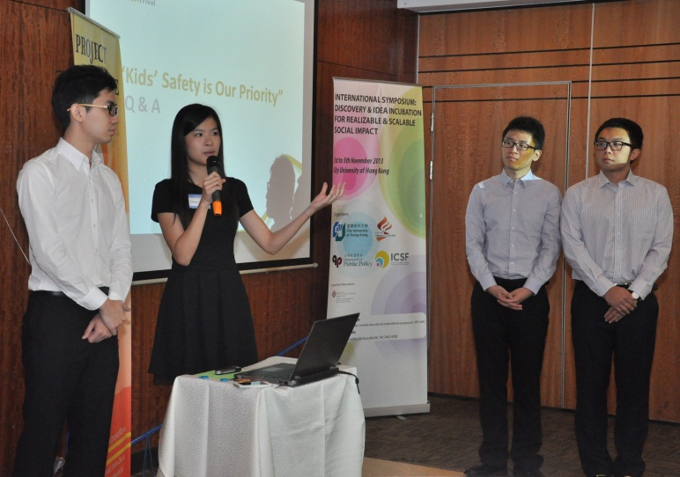*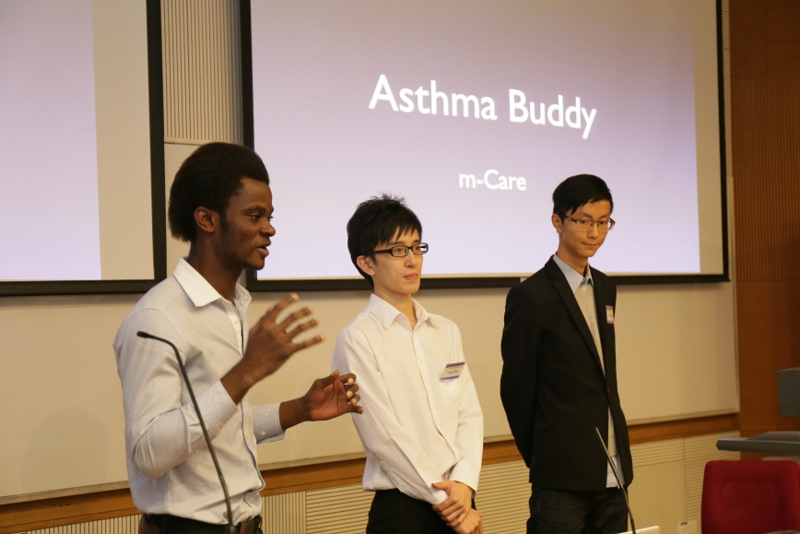*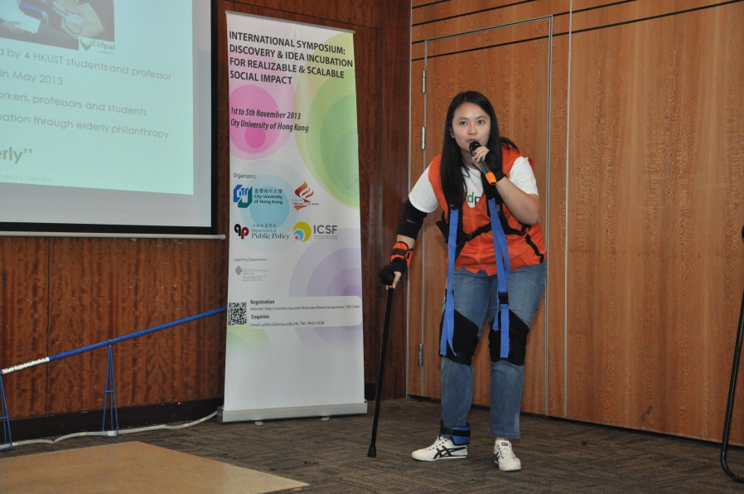

#### ELIGIBILITY

* Students, social innovators and entrepreneurs wanting to make an impact on social or environmental problems.
* Contestants can be individuals or teams of no more than 5 members.
* Each contestant may not submit more than 2 entries for the award.

**ENTRY SUBMISSIONS and REGULATIONS**

* Entries must be submitted in ENGLISH only.
* The entries must be made using the official entry form and be no longer than 750 words length in total.
* Once your entry is submitted, it may not be modified.
* Entries shortlisted as finalists will be expected to attend both the pitching and symposium.
* The Awards are classified into Champion, First Runner-up, Second Runner-up.
* All contestants must register for the symposium and pay the appropriate registration fee when submitting their application.
* Registration fees for the symposium will be waived for contestants registered as full-time students at any university or college.
* Teams should not add or change team members once they have submitted their entry summary to the judging panel.

**PRESENTATION and CONSULTATION**

* All entries must be submitted through the online registration platform by 22nd October 2014.
* The Finalists will be notified of their successful entry on 24th October 2014 and are required to attend the pitching on 31st October 2014.
* Finalists will be informed by email and by announcement on the Project Flame Website
* Finalists have 4 minutes to pitch their enterprising ideas and will then be questioned by a panel of experts.

#### JUDGING PANEL

The Final Judging Panel, chaired by Michael Norton, will consist of both local and international experts, such as Adam O’Boyle, Josephine Lee, and Kelvin Cheung.

#### Judging criteria will include:

**TERMS and CONDITIONS**

* The organizers reserve the right to invite entrants to attend an interview during the shortlisting.
* All decisions of the Judging Panel will be final and binding.
* Finalists maybe required to assist the Organizer in associated publicity activities.
* All entries and any copyright subsisting in the entries will remain the property of the contestant. Each contestant shall have the sole responsibility for securing any potential intellectual property rights. The organizer shall not be liable for any costs incurred or loss, damage, injury, expense or liability suffered by contestant in relation to any failure to successfully secure any intellectual property rights related to the entries as a result of participation in the contest.
* Any form of plagiarism will result in disqualification.

Register

To Yutian, please add link to the pitching entry form in registration tag

[Registration](http://www6.cityu.edu.hk/projectflame/symposium/#registration)

### Online Registration

All participants are required to register for the symposium.

Pitching

Registration

Symposium

Registration

Symposium Registration form <https://docs.google.com/forms/d/1qWyapPyVvm1hXo8ygKs987Hf7ETC9fmCacbOgtwnegI/viewform>

Pitching Entry Registration form

<https://docs.google.com/forms/d/1V6OVr7GXqCDgZhew-iJo76blHf-HRrko5ISuN25NKBc/viewform>

[Contact us](http://www6.cityu.edu.hk/projectflame/symposium/" \l "contactus)

**Registration / Enquiry:**

Tel: (852)3442-8273

Email: qianqmai2@cityu.edu.hk

**Ways to CityU**

<http://www6.cityu.edu.hk/wayfinder/GettingToU/bymtr-kt1.htm>

(put logos here)